SMART CONTROLLING USING IOT

C. KARTHIK,
B.E- ECE,
Paavai Engineering College,
Namakkal-637018,
Karthikchandrasekaran98650@gmail.com

V.PURUSOTHAMAN,
B.E-ECE,
Paavai Engineering College
Namakkal-637018,
purusothmanece@gmail.com

P. LOGESH,
B.E-ECE,
Paavai Engineering College,
Namakkal-637018,
logeshmeena98@gmail.com

Mr.S.LOGANATHAN,M.E.,
AP,ECE
Paavai Engineering College,
Namakkal-63701
logumepaavai@gmail.com

Abstract— The Smart Sensing Hardware - Sensor sends data through an Access Point through the firewall to the Cloud. From the Cloud, it is accessible by the user from any smart device. Ubiquitous sensing enabled by Wireless Sensor Network (WSN) technologies covers across many areas. This offers the ability to control and monitoring the electrical and electronics appliances. The proliferation of these devices in a communicating and actuating network creates the Internet of Things (IOT), wherein, sensors and actuators blend seamlessly with the environment around us, and the information is shared across platforms in order to develop a common operating picture (COP). This project presents a Cloud centric vision for worldwide implementation on Internet of Things. A Cloud implementation using Azure, which is based on interaction of private and public Clouds is presented. We conclude our IOT vision by expanding on the need for convergence of WSN, the Internet and distributed computing directed at technological research community (cloud).

Keywords—Internet of Things, IoT, Azure IoT Hub, Mobile Services, DHT11, Temperature and Humidity

Introduction

The next wave in the era of computing will be outside the realm of the traditional desktop. In the Internet of Things (IOT) paradigm, many of the objects that surround us will be on the network in one form or another. Radio Frequency Identification (RFID) and sensor network technologies will rise to meet this new challenge, in which information and communication systems are invisibly embedded in the environment around us. This results in the generation of enormous amounts of data which have to be stored, processed and presented in a seamless, efficient, and easily interpretable form.
This model will consist of services that are commodities and delivered in a manner similar to traditional commodities. Cloud computing can provide the virtual infrastructure for such utility computing which integrates monitoring devices, storage devices, analytics tools, visualization platforms and client delivery. The cost-based model that Cloud computing offers will enable end-to-end service provisioning for businesses and users to access applications on demand from anywhere.
Smart connectivity with existing networks and context-aware computation using network resources is an indispensable part of IOT. With the growing presence of Wi-Fi and 4G-LTE wireless Internet access, the evolution toward ubiquitous information and communication networks is already evident. However, for the Internet of Things vision to successfully emerge, the computing paradigm will need to go beyond traditional mobile computing scenarios that use smart phones and portables and evolve into connecting everyday existing objects and embedding intelligence into our environment. For technology to disappear from the consciousness of the user, the Internet of Things demands: (1) a shared understanding of the situation of its users and their appliances, (2) software architectures and pervasive communication networks to process and convey the contextual information to where it is relevant, and (3) the analytics tools in the Internet of Things that aim for autonomous and smart behavior. With these three fundamental grounds in place, smart connectivity and context-aware computation can be accomplished.
The term Internet of Things was first coined by Kevin Ashton in 1999 in the context of supply chain management. Although the definition of Things ‘has changed as technology evolved, the main goal of making computer sense information without the aid of human intervention remains the same. A radical evolution of the current Internet into a Network of interconnected objects that not only harvests information from the environment (sensing) and interacts with the physical world (actuation/command/control), but also uses existing Internet standards to provide services for information transfer, analytics, applications, and communications.
Fueled by the prevalence of devices enabled by open wireless technology such as Bluetooth, radio frequency identification (RFID), Wi-Fi, and telephonic data services as well as embedded sensor and actuator nodes, IOT has stepped out of its infancy and is on the verge of transforming the current static Internet into a fully integrated Future Internet. The next revolution will be the interconnection between objects to create a smart environment. Only in 2011, the number of interconnected devices on the planet overtook the actual number of people. Currently there are 9 billion interconnected devices and it is expected to reach 24 billion devices by 2020. According to the GSMA, this amounts to $1.3 trillion revenue opportunities for mobile network operators alone spanning vertical segments such as health, automotive, utilities and consumer electronics.

proposedsystem
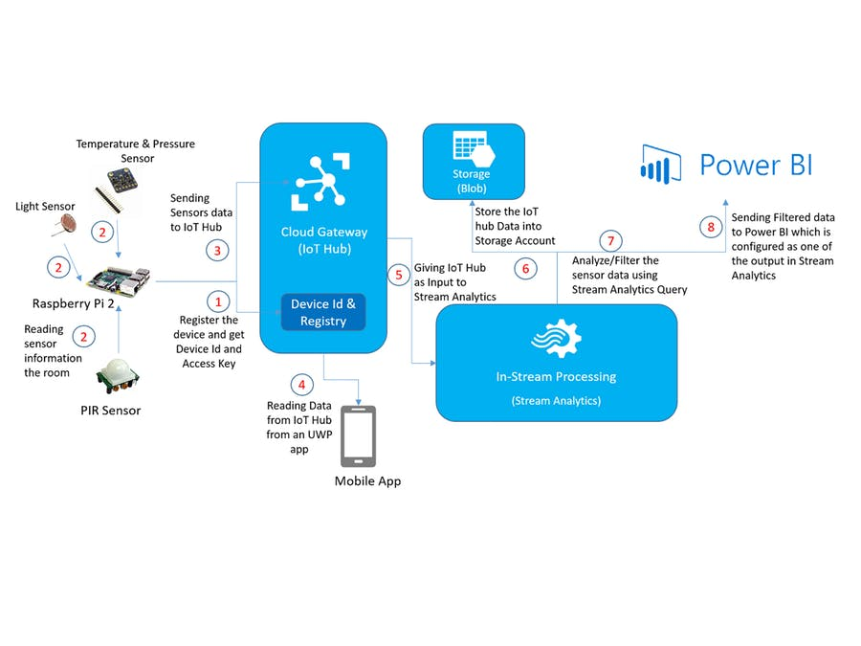

Figure.1 Block diagram

The trend of the market is the information to be available independently of the places or the geographic location. For this reason, currently, the internet is used to bring a real-time interaction among devices that will not be possible with other medium. Simply, all the information gathered from the sensor must be available in the cloud to be managed and controlled, Thus, a central point of management exits where the information from the sensors remotely distributed is stored. Furthermore, the industrial processes make necessary to implement wireless communication system to transmit the signals generated by the sensor making up the controlled loop. Hence the modelling, design and implementation of a remote wireless system applied to an industrial process is done. Then, the reliability of the system can be analyzed. The rest of the paper is organized as follows Section II present a description of the implemented system according to the IOT. Section III shows the analysis and Application deployment of the results obtained. Finally, Section IV show the conclusions.

DESIGN AND DEVELOPMENT

In this section, we will describe the implemented sensor’s system. The system uses three type of sensor (temperature, motion, GPS module) for sensing. The sensors sent the information to the Internet through the Access Point. More exactly to the Microsoft Azure Cloud IOT Hub server (a platform designed for the IOT). Thus, the information gathered can be monitored from anywhere in the world. Once the data is stored in the Cloud

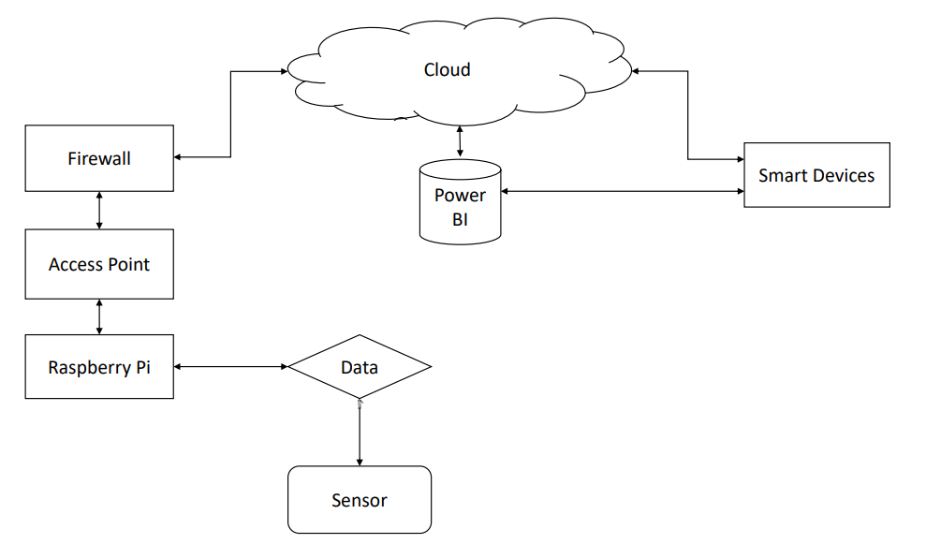
Figure 2 System Flow chart

IMPLEMENTATION

Raspberry pi as server: the raspberry pi with windows 10 IOT core OS section basically has an azure application configured as coordinator to receive the data coming from sensors. The frames coming from different sensor is received and stored, from the received data the required information is extracted and display in the server which acts as central monitoring station. The raspberry pi unit does the additional function of updating the status using a local area network, this helps to monitor the status sitting at their chamber.

V. HARDWARE REQUIREMENTS

  - Temperature and Humidity Sensor
  - PIR Motion Sensor

A. Temperature and Humidity Sensor

We will use the DHT11 Temperature sensor and which is most accurate with an accuracy of +/-0.4C.and working based on the principal of thermocouple. DHT11 Temperature and Humidity sensor is shown in figure 3.3.
Advantage of DHT11 sensor
- It measures temperature more accurately than thermistors.
- It output in digital.

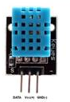

Figure 3. Temperature and Sensor (DHT11)

  - LED

We will use the cloud to device telemetry to control the LED that is placed in PCB with few Resistances. LED is shown in figure 4.

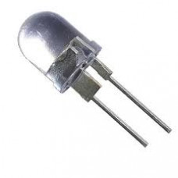
Figure 4 LED

APPLICATION
The project contains two Universal Windows Applications (on the Universal Windows Platform, UWP) that share about 99% of the code. One is targeted towards the Raspberry Pi (or ARM) and the other is targeted towards the x86 or x64 platforms.

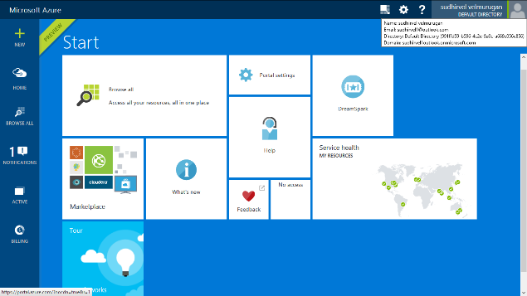

Figure 5 Azure Portal

The IOT version of the application runs on the Raspberry Pi and reads the temperature from the MCP3008. The application sends telemetry events to the Azure IOT Hub and the Signal R hub. This version will also listen for commands from the Azure IOT Hub.
The client version, started on a computer, will listen for sensor updates from the SignalR hub and display them on screen. This version will also send commands to the IOT version via the Azure IOT Hub. At the heart of the application is the MCP9808 library built as a separate project that can be reused in other applications. This project is developed as a UWP library that can be used in any Windows 10 application. If the library is used on a device that does not have an I2C bus the library will not return any device object. This approach can be used to “detect” a sensor.

VII.RESULT AND DISCUSSIONS

This Project provides the automated monitor the real time data and tracking, Industrial automation and manufacturing Factories etc.,

Final System

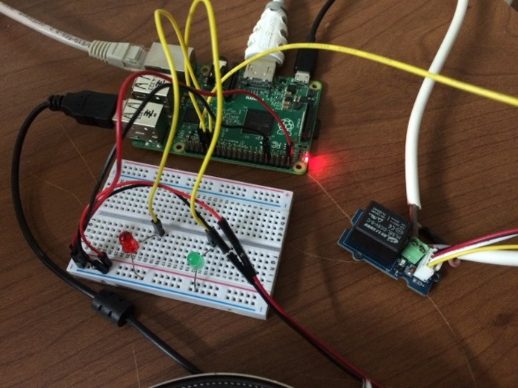
Figure 8. 1 Proposed System
Client App

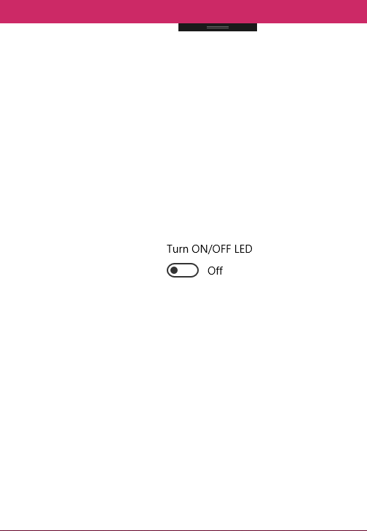

Figure 7 Client App
Server App
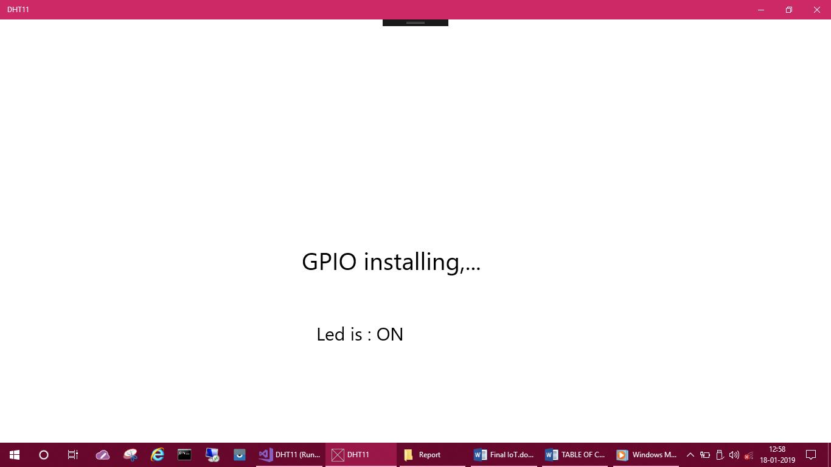

Figure 6 Server App

In this project the design for mobile app to the client. a database is created on azure IOT hub and mobile services are also created. The interface between mobile app and database is done. Sensors are successfully connected to raspberry pi and wireless communication is achieved. The sensors and microcontroller are successfully interfaced and wireless communication is achieved between various nodes. All observations and experimental tests prove that this project is a complete solution to field activities. Implementation of such a system in the field can definitely help to improve the home automation.

VIII.REFERENCES

- Atzori,A.lera.G.Morabito (2014), The Internet Of Things: A Survey, Comput Netw. 54(2014)2787-2808.
- Corso.F, Camargo.Y, Ramirez.L- (2007) “WIRELESS SENSOR SYSTEM ACCORDING TO THE CONCEPT OF IoT – INTERNET OF THINGS” Computational Science and Computational Intelligence (CSCI), 2014.International Conference On, Vol.1,PP.52,58, 10-13 March 2007.
- Cena,A.Valenzano, and S.Vitturi (2014) “WIRELESS EXTENSIONS OF WIIRED INDUSTRIAL COMMUNICATIONs NETWORKS” In Industrial Informatics, 2007 5th International Conference On, Vol.1,2014.
- Edi Wan.g .NET ASP.NET, Windows 10 Development, IOT. Windows 10 IOT Core Basic: Online Documentation: http://www.EDI.WANG.
- Jerry Nixon Microsoft Developer Evangelist “Template 10 UMPProject Template “: http://aka.ms/t10.
- Microsoft Azure Documentation for Azure IOT Hub: http://azure.microsoft.com/en-us/documentation/articles/iot-hub-csharp-csharp-getstarted/.

- Microsoft C# and .NET Documentation: http://azure.microsoft.com/en-us/documentation/articles/iot-hub-csharp-csharp-c2d/.

.

